August School Council Agenda
Meeting
Date: August 30th 6:00pm
Start: 6.00pm
Invited Participants:
Non DET: Kylie O’Hagan,, Sarah Crotty, Jaqui Deppeler, Anna Rapetti, Mary Hawira, Lisa Neagle
DET: Jayden Andrea,
Apologies:
Chair: Sarah Crotty
Minutes: Anna
Quorum requirements:
A school council meeting must operate with a quorum. A quorum requires not less than one half of school council members currently holding office to be present at the meeting and the majority of members present must not be Department employees. Any parent members on school council who also work for the Department are counted as Department employees for the purpose of a quorum.
Time Extension:
School council meetings should require no longer than 2 hours, regardless of the setting. If business has not been concluded by the scheduled closing time for the meeting, the chair should ask councilors whether they wish to defer the rest of the business until the next meeting or to extend the meeting by a specified period of time (for example, 15 minutes). A motion is necessary if council wants to extend the meeting.
Conflict of interest:
If a member of the council or their immediate family has a direct conflict of interest (including a pecuniary interest) in with a matter under discussion at a school council meeting that member:
· must not be present:
o during the discussion unless invited to do so by the person presiding at the meeting
o when a vote is taken on the matter
· may be included in the quorum for that meeting
The declaration of interest should be included in the minutes of the meeting.
If the President is unable to preside over a meeting and no Vice President has been appointed, a member of the council who is not a Department member can be voted to chair the meeting.

Welcome:  Acknowledgement of traditional owners. | I would like to acknowledge the traditional owners of the lands on which we meet today. I pay respect to Elders past, present and emerging.
Quorum | Chairperson acknowledges that a quorum was present.
Minutes of the Previous Meeting | Motion:  That the minutes of the previous meetings held in May be passed as a true and accurate reflection of the meeting. | Moved: Jayden  Seconded: Kylie  Vote: Accepted
Committees | Fundraising - Angela, Trish, Tania  Finance - Jaqui  Grounds / Maintenance - Heath Brown, Beau Sayers, Sharon, Will Reid?
Principal’s report | Staffing updates: Specialist and Disability Inclusion For Term 3 has being taken over by Adele  Junior School Council Update- Students have been conducting assemblies and discussing initiatives in their meetings. Future council meetings will involve a JSC update. We are almost ready for this.  Chess in term 3- There will be an inter school tournament on August 29th term 3 at Alice Miller School. 12 students selected.  Student numbers- 57  Plumbing works - completed last school holidays.  Pergola -Work to begin in September holidays now.  Bunnings BBQ - September 18th Helpers required
Child Safety | Road- Trees have left visibility from our school to the road. Might be better for advertising but not so much for safety. Even if this is not a major threat.  I have emailed Vicroads and advised that the trees were not supposed to be cut back so far. They came out to inspect the tree. They are to get back to us about who pays for the fence.
Policies
Fundraising: | Targets? From Fundraising..
 | Christmas Raffle: target has not been decided yet, but Katie says that the proceeds from the Christmas raffle are usually used to cover the costs of the PAC hire for the end of year concert.  Motion: We approve the hire of the hall for the end of year concert as a target for the Christmas Raffle.  That School Council approve the following fundraising events for the 2022 School year:  Fundraising committee to decide on targets early in the new council.  P and L Colour Run  Value Approved at $200 so that there's a little extra wiggle room in case something changes with buying the powder. | Moved: Jayden  Seconded: Kylie  Accepted  Moved: Jayden  Seconded: Anna  Vote: All Accepted

Finance report- Jaqui | Endorsement of reports.  Motion:  That School Council move that the presented finance reports be accepted as a true and correct depiction of the Bolinda PS school finances for the month of May, June and July. | Moved: Jayden  Seconded: Anna  Accepted.

Curriculum Days | Motion: That school council approves the following dates as student free curriculum days for Bolinda PS.  Melbourne Cup day - Oct 31st 2022 First Aid Training  Data day- 28th Nov 2022 Regional Data coach/ EIL End of year.  Numeracy in term 3- August 12th: Numeracy | Moved: Jayden  Seconded: Sarah  Accepted.
Camp | Motion:That School Council approves the City Camp on the 7th to the 9th of December for 3-6 students.  Suggested cost $250 per child. School to subsidise further costs.  Jayden to check if there are any grants or funding to support camps in schools. | Moved: Jayden  Seconded: Jaqui  Accepted.
Solar Replacement | See emails.  Motion: To enter into the GGS program to fund extra solar panels provided the existing solar panels are replaced free of charge. | Moved: Jayden  Seconded: Anna  Accepted.
Business arising from the minutes:

General Business. | - If anything can be addressed prior to council, please let me know. Last meeting went long.

Correspondence | In: Pergola Information  Camp information- Now Approved.
Out:
Assembly- Switch to indoors
BBQ Notification.
Power outage

Next Meeting

Close of Meeting: | 6:45pm

Signed by the Chairperson: ______________________________
President or person who presided at the previous meeting to sign once minutes have been approved by school council
Date: ______________________
NOTE: RECORDS AND INFORMATION MANAGEMENT
School council minutes, agenda and correspondence are considered permanent records and are to be maintained in the school until such time as they can be transferred to the Public Record Office Victoria.

Anna Rapetti <anna.rapetti@education.vic.gov.au>
To:
Angela Cook
Thu, 26 May at 08:48
Hi Angela,

I agree

Thanks

Anna
From: Angela Cook <angscook@yahoo.com>
Sent: Wednesday, 25 May 2022 5:10 PM
To: kwoods88@hotmail.com; Jaqui Deppeler <jde72100@bigpond.net.au>; Lisa Neagle <lisaneagle@gmail.com>; Mary Hawira <maryhawira@yahoo.com>; Sarah <sarahl.crotty@gmail.com>; Anna Rapetti <Anna.Rapetti@education.vic.gov.au>; Jayden Andrea <Jayden.Andrea@education.vic.gov.au>
Subject: Re: Bunnings BBQ

Hi everyone
Could you please email me your agreement asap so we can sort out the ordering if you haven't already done so.
Thanks heaps
Angela
Sent from Yahoo Mail on Android

On Wed, 25 May 2022 at 1:22 pm, Angela Cook
<angscook@yahoo.com> wrote:
Thanks, Kylie.
Sent from Yahoo Mail on Android

On Wed, 25 May 2022 at 12:22 pm, Kylie O'Hagan
<kwoods88@hotmail.com> wrote:
Hello, I am happy with it. Regards Kylie

Get Outlook for Android

From: Angela Cook <angscook@yahoo.com>
Sent: Monday, May 23, 2022 4:29:39 PM
To: Jaqui Deppeler <jde72100@bigpond.net.au>; Kylie <kwoods88@hotmail.com>; Lisa Neagle <lisaneagle@gmail.com>; Mary Hawira <maryhawira@yahoo.com>; Sarah <sarahl.crotty@gmail.com>; Anna.Rapetti@education.vic.gov.au <Anna.Rapetti@education.vic.gov.au>; Jayden Andrea <jayden.andrea@education.vic.gov.au>
Subject: Bunnings BBQ

Hi everyone

Trish and I have updated the P&L for the Bunnings BBQ (expenses and revenue). We had, I guess, tentatively approved the bbq at the end of last year with the goal of funding the bus to swimming. Jayden is that still an appropriate target?
Now that we have a more accurate costing, we'd like to get SC's approval so Trish can get ordering the food that needs to be ordered ahead of time. Could everyone please take a look at the P&L and email your approval (or let me know if you have any issues with it) as Trish would like to get onto it this week.
Google Docs – create and edit documents online, for free.

Google Docs – create and edit documents online, for free.
Create a new document and edit with others at the same time – from your computer, phone or tablet. Get stuff don...

Thanks heaps.
Angela

Mary Hawira <maryhawira@yahoo.com>
To:
Angela Cook
Wed, 25 May at 22:11
Looks good to me

lisaneagle@gmail.com <lisaneagle@gmail.com>
To:
Angela Cook
Wed, 25 May at 18:17
Agree 👍🏼

Sarah Crotty <sarahl.crotty@gmail.com>
To:
Angela Cook
Wed, 25 May at 11:36
Hi Angela,
Happy for you to go ahead and purchase the supplies for the BBQ.
Kind regards,
Sarah
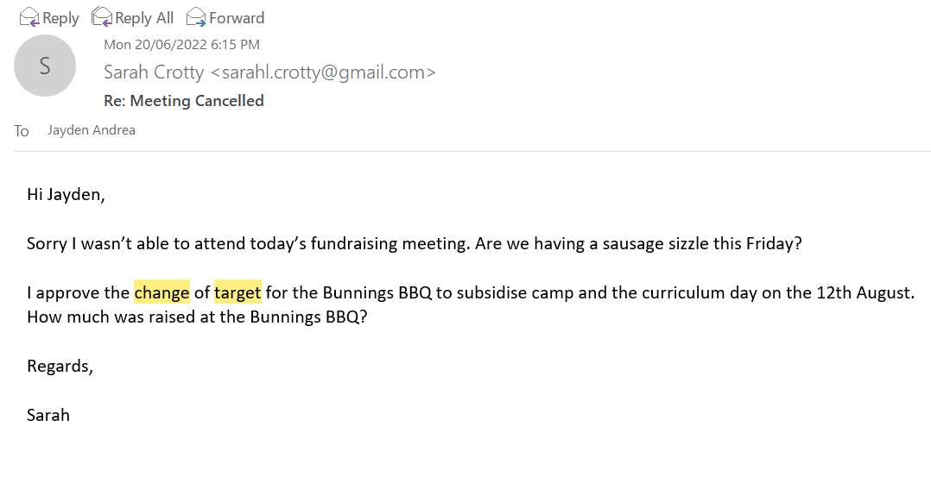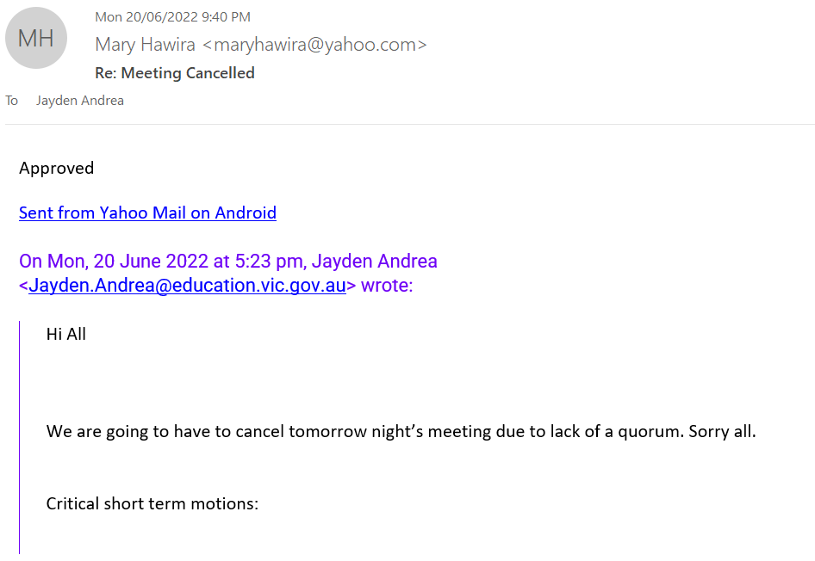
Bolinda Primary School – Fundraising Approval and Profit Recording

Activity | Colour Run
Planned Date | Term 4 2022
Organiser(s)
Funds to be used for | TBA

EXPENSES | Budgeted Expenses | Actual Expense
Holi Colour Powder 7 Pack | $130.00
Freight / Postage | $28
TOTAL | $158.00

REVENUE | Estimated Revenue | Actual Revenue
Child Sponsorship | $1000
TOTAL | $1000

APPROVAL DATES | Budget & Activity approval | Actual Profit/Loss
Value approved | $200.00 | $
Fundraising Com. Approval
School Council Approval
Expenditure and event approval must be given prior to event AND/OR 20% of budgeted expenses being spent and actual values provided to the first meeting held after the event/activity. Total revenue and/or expenses >$2500 must be approved through school council and the profit and loss tabled to school council.
IF GOODS SOLD
Stocktake at start of period
Stocktake at end of period

LABOUR / TIME | Volunteer hours | Staff hours
Planning / Preparation |  | 1 hour
Running activity |  | 2 hours
Pack-up / Post activity |  | 0.5 hours
GST treatment – although Fundraising Wheel recommends GST inclusive treatment, all accounting was GST exclusive as per current procedures for fundraisers.
